A TECHNICAL REPORT ON STUDENTS INDUSTRIAL WORK EXPERIENCE SCHEME (SIWES)

COVER PAGE

AT

Mr. Ojong Welding and Fabrication iNDUSTRY,
ABAKPA, OGOJA, CROSS RIVER STATE

BY

MONKOM ANTHONY UNAH
ET/ME/ND/23/012

DEPARTMENT OF MECHANICAL ENGINEERING TECHNOLOGY FEDERAL POLYTECHNIC, MUBI.

JULY, 2025

A TECHNICAL REPORT ON STUDENTS INDUSTRIAL WORK EXPERIENCE SCHEME (SIWES)

TITLE PAGE

AT

Mr. Ojong Welding and Fabrication INDUSTRY,
ABAKPA, OGOJA, CROSS RIVER STATE

FROM: 7TH OCTOBER, 2024
TO: 25TH JANUARY, 2025

BY

MONKOM ANTHONY UNAH
ET/ME/ND/23/012

THIS TECHNICAL REPORT IS SUBMITTED TO THE DEPARTMENT OF MECHANICAL ENGINEERING TECHNOLOGY

IN PARTIAL FULFILMENT OF THE REQUIREMENTS FOR THE AWARD OF NATIONAL DIPLOMA (ND) IN MECHANICAL ENGINEERING TECHNOLOGY,
FEDERAL POLYTECHNIC, MUBI

JULY, 2025

APPROVAL PAGE
This SIWES report written by Monkom Anthony Unah with registration number ET/ME/ND/23/012 was certified and approved by the following

Mr. Philip Abbas J. _____________ _____________
SIWES Supervisor Sign Date

Dr. Mohammed Bashir A. _____________ _____________
SIWES Coordinator Sign Date

Mr. Cosmas Tizhe _____________ _____________
Head of Department Sign Date

DEDICATION
This work is dedicated to my beloved parents for leading me into intellectual pursuit by giving me the financial support. In addition to the enormous contribution (financially and morally) made by my brothers and family members are too many to mention.

ACKNOWLEDMENTS
All glory be to God almighty the creator of heaven and earth for his sufficient grace throughout the period of my SIWES program and I thank God for giving this great opportunity.
I also thank my family, friends and relative for supporting me morally and financially throughout my education and successful completion of my student industrial work experience scheme (SIWES) program.
I would also like to express my infinite thanks to the entire management and staff of Government Technical College for honoring me and accepting my application and helpful relation accorded to me during the period of my attachment.
I also thank my industrial supervisor for his dedication, concern and contribution during the period of my SIWES program. Finally, I will like to show my appreciation to my Head of Department, my SIWES Supervisor and all staff of Mechanical Engineering Federal Polytechnic Mubi, Adamawa state of Nigerian

SUMMARY
The report is structured into four chapters detailing the Students Industrial Work Experience Scheme (SIWES) and the practical projects undertaken. Chapter One introduces SIWES, covering its background, objectives, and significance in bridging the gap between theory and practice. Chapter Two focuses on construction projects, including the fabrication of a panel door, and palm oil presser. Chapter Three contains construction of window protector, palm nut pounder and selector, and a handrail with galvanized pipes. Chapter Four of this report contains the conclusion and recommendations for improving industrial training programs.

TABLE OF CONTENT

COVER PAGE i
TITLE PAGE ii
APPROVAL PAGE iii
DEDICATION iv
ACKNOWLEDMENTS v
SUMMARY vi
TABLE OF CONTENT vii
LIST OF FIGURES ix
CHAPTER ONE 1
INTRODUCTION 1
1.1 Brief history of SIWES 1
1.2 Aim and objectives of SIWES 2
1.3 Brief History of Organization 2
1.4 Organizational chart 3
CHAPTER TWO 4
2.1 CONSTRUCTION OF PANEL DOOR 4
2.1.1 Materials/Tools Used 4
2.1.2 Welding Process (Procedure) 4
2.1.3 Finishing 4
2.1.4 Precautions Observed 4
2.2 CONSTRUCTION OF PALM OIL PRESSER 6
2.2.1 Materials/Tools Used 6
2.2.2 Fabrication Process (Procedure) 6
2.2.3 Finishing 6
2.2.4 Precautions Observed 7
CHAPTER THREE 8
3.1 CONSTRUCTION OF WINDOW PROTECTOR 8
3.1.1 Materials/Tools Used 8
3.1.2 Welding Process (Procedure) 8
3.1.3 Finishing 9
3.1.4 Precautions Observed 9
3.2 CONSTRUCTION OF A PALM NUT POUNDER AND SELECTOR 11
3.2.1 Materials/Tools Used 11
3.2.2 Fabrication Process (Procedure) 11
3.2.3 Finishing 11
3.2.4 Precautions Observed 11
3.3 CONSTRUCTION OF A HANDRAIL WITH GALVANIZED PIPE 13
3.3.1 Materials Used 13
3.3.2 Welding Process (Procedure) 13
3.3.3 Finishing 14
3.3.4 Precautions Observed 14
CHAPTER FOUR 16
CONCLUSION AND RECOMMENDATION 16
4.1 Conclusion 16
4.2 Recommendations 16
REFERENCES 18

LIST OF FIGURES
Figure 1.1: Organizational Chart………………………………………………………….. 4
Figure 2.1: Panel door…………………………………..………………………………….. 6
Figure 2.2: Palm Oil Presser……………………………………………………………….. 8
Figure 3.1: Window protector……………..……………………………………………….. 11
Figure 3.2: Palm Nut Pounder and Selector……………………………………………….. 13
Figure 3.3: Handrail with Galvanized Pipe……………………….……………………….. 16

CHAPTER ONE

INTRODUCTION

1.1 Brief history of SIWES
SIWES was founded in 1973 by Industrial Training Funds (ITF) to address the problem of tertiary institution graduates' lack of appropriate skills for employment in Nigerian industries. The Students' Industrial Work Experience Scheme (SIWES) was founded to be a skill training programme to help expose and prepare students of universities, Polytechnics and colleges of education for the industrial work situation to be met after graduation.
This system facilitates the transfer from the classroom to the workplace and aids in the application of knowledge. The program allows students to become acquainted with and exposed to the experience required in handling and operating equipment and machinery that are typically not available at their schools.
Prior to the establishment of this scheme, there was a rising concern and trend among industrialists that graduates from higher education institutions lacked appropriate practical experience for employment. Students who entered Nigerian universities to study science and technology were not previously trained in the practical aspects of their chosen fields. As a result of their lack of work experience, they had difficulty finding work.
As a result, employers believed that theoretical education in higher education was unresponsive to the needs of labor employers. Thousands of Nigerians faced this difficulty till 1973. The fund's main motivation for establishing and designing the scheme in 1973/74 was launched against this context.
The Industrial Training Funds (ITF) organization decided to aid all interested Nigerian students and created the SIWES program. The federal government officially approved and presented it in 1974. During its early years, the scheme was entirely supported by the ITF, but as the financial commitment became too much for the fund, it withdrew in 1978. The National Universities Commission (NUC) and the National Board for Technical Education (NBTE) were given control of the scheme by the federal government in 1979. The federal government handed over supervision and implementation of the scheme to ITF in November 1984. It was taken over by the Industrial Training Fund (ITF) in July 1985, with the federal government bearing entire responsibility for funding.

1.2 Aim and objectives of SIWES
The Industrial Training Fund’s Policy Document No. 1 of 1973 which established SIWES outlined the objectives of the scheme as:
- Provide an avenue for students in Institutions of higher learning to acquire industrial skills and experience in their respective courses of study.
- Prepare students for the Industrial Work situation they are likely to experience after graduation.
- Expose students to work methods and techniques of handling equipment and machinery that may not be available in their Institutions.
- Make the transition from school to the world of work easier; and enhance students’ networks for later job placements.
- Provide students with an opportunity to apply their knowledge to real work situations, thereby bridging the gap between theory and practice; and vi. Enlist and strengthen Employers’ involvement in the entire educational process; thereby preparing the students for employment in Industry and Commerce.

Orientation Exercise
The first day I reported to my Students Industrial Work Experience Scheme (SIWES) at Mr. Ojong’s Welding and Fabrication Industry. I went to the training center where I gave a letter to the factory manager. The manager gave me another letter to the Chief Mechanical Engineering (CME), then finally the chief mechanical engineer gave me a letter to my first section in the industry that is the fabrication section. I was taken around the sections and was introduced to the machines equipment and tools used in the section as well as the staff working in the section by the engineer in charge of the section. I was encouraged not to be absent and ask question whenever I need clarification and to adhere strictly to the instruction given to me regarding the safety precautions.

1.4 Brief History of Organization
Mr. Ojong Welding and Fabrication Industry was established in 2016 by Mr. Ojong, a skilled welder and fabricator with over two decades of experience in the industry. The welding workshop is strategically situated at Government Technical College, Ogoja, Cross River State, Nigeria. This location was chosen for its accessibility and proximity to both residential and commercial areas, making it convenient for a wide range of clients.
Since its inception, the industry has grown from a small workshop to a well-known establishment in the region. Initially, the focus was on providing basic welding services, such as the repair of household items, gates, and fences. However, due to the high quality of work and the growing demand for more specialized services, the industry quickly expanded its offerings. Mr. Ojong Welding and Fabrication Industry invested in advanced welding equipment and training for its staff. This enabled the company to take on larger projects, including the fabrication of industrial machinery parts, custom metal structures, and complex construction components. The industry also started offering mobile welding services to cater to clients who needed on-site repairs and installations. The company had established a reputation for reliability and excellence, attracting clients from various sectors, including construction, manufacturing, and agriculture. Mr. Ojong’s commitment to continuous improvement and customer satisfaction has been a driving force behind the company's success, Figure 1.1 shows the organizational chart of the organization.

1.5 Organizational chart
WORKSHOP
ASST. MANAGER

WORKSHOP
APPRENTICE
& STUDENTS

SECURITY
CHIEF MECHANICAL ENGINEER
WORKSHOP
MANAGER
ACCOUNTANT
SECRETARY

Figure 1.1: Organizational Chart

CHAPTER TWO
WORK EXPERIENCE

2.1 CONSTRUCTION OF PANEL DOOR

2.1.1 Materials/Tools Used
The materials and tools used for the fabrication of the panel door included mild steel sheets for the door panels, steel angles for the frame, welding rods, hinges, a lockset, and paint for finishing. Figure 2.1 shows the constructed panel door of size 838mm x 1955mm. The tools included a welding machine, angle grinder, measuring tape, square, welding helmet, gloves, and a drill.

2.1.2 Welding Process (Procedure)
- The fabrication process began with measuring and cutting the steel sheets and angles to the required dimensions.
- The frame was assembled using steel angles, ensuring all corners were square.
- After assembling the frame, the door panels were welded onto the frame, making sure to create strong joints.
- Once the welding was complete, the edges were ground smooth to remove any sharp edges.
- The hinges were then attached to the frame, and holes were drilled for the lockset installation.

2.1.3 Finishing
For finishing, the entire structure was cleaned to remove any welding slag or debris. A primer was applied to prevent rust, followed by a coat of paint to enhance appearance and durability. The door was then inspected for any imperfections and touched up as necessary.

2.1.4 Precautions Observed
During the fabrication process, several precautions were observed. Safety gear, including gloves, welding helmet, and protective clothing, was worn to prevent injuries.
- The work area was kept clean and free of flammable materials to reduce the risk of accidents.
- Proper ventilation was ensured while welding to avoid inhaling harmful fumes, and all tools were checked for functionality before use to prevent malfunctions.
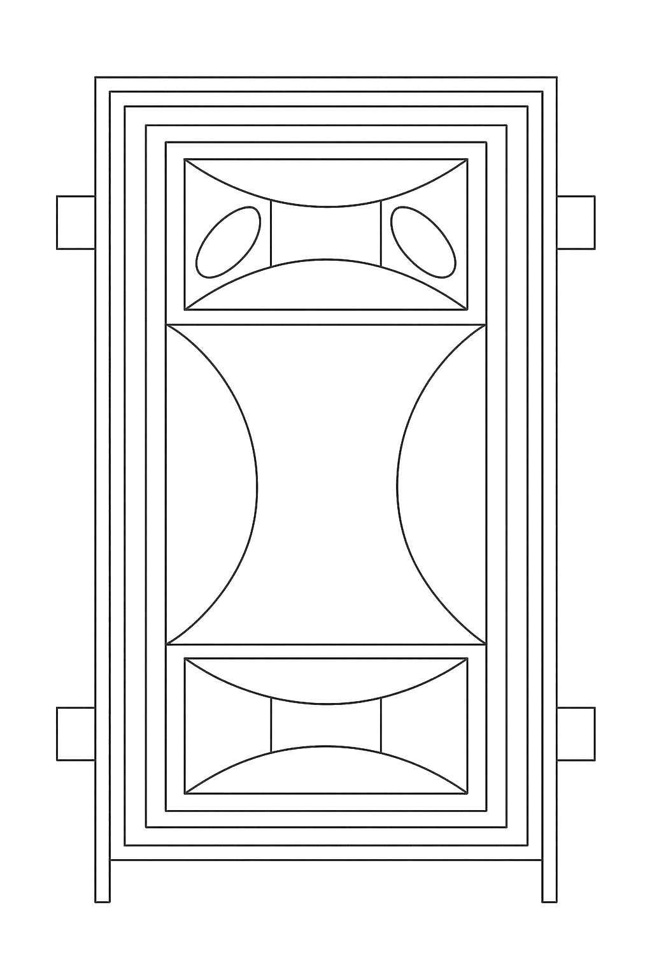
1955mm
838mm
Figure 2.1: Panel door

2.2 CONSTRUCTION OF PALM OIL PRESSER

2.2.1 Materials/Tools Used
The materials and tools used for the fabrication of the palm oil presser included mild steel sheets for the housing, a hydraulic or screw pressing mechanism, steel rods for support, bearings, a motor for automated operation, bolts, and paint for finishing. The constructed palm oil presser is shown in Figure 2.2. The tools included a welding machine, angle grinder, lathe machine, measuring tape, square, welding helmet, gloves, and a drill.

2.2.2 Fabrication Process (Procedure)
- The fabrication process began with measuring and cutting the steel sheets and rods to the required dimensions.
- The frame was assembled using steel rods and sheets to ensure a strong and stable structure.
- The pressing chamber was constructed, incorporating either a hydraulic or screw press mechanism for efficient extraction.
- Bearings and the motor were installed to facilitate smooth operation.
- The oil collection tray and discharge outlet were fixed to direct the extracted oil properly, 50 litres of oil was collected.
- All edges and welded joints were ground smooth to eliminate sharp edges and improve safety.

2.2.3 Finishing
For finishing, the entire structure was cleaned to remove welding slag, grease, and debris. A primer was applied to prevent rust, followed by a coat of paint to enhance durability and aesthetics. The palm oil presser was then tested for efficiency, and necessary adjustments were made to optimize performance.

2.2.4 Precautions Observed
During the fabrication process, several safety precautions were observed:
- Safety gear, including gloves, a welding helmet, and protective clothing, was worn to prevent injuries.
- The work area was kept clean and free of flammable materials to minimize accident risks.
- Proper ventilation was ensured during welding to prevent inhalation of harmful fumes.
- All tools and electrical components were checked for proper functionality before use to prevent malfunctions.
- Moving parts were securely fitted to prevent operational hazards during testing and use.
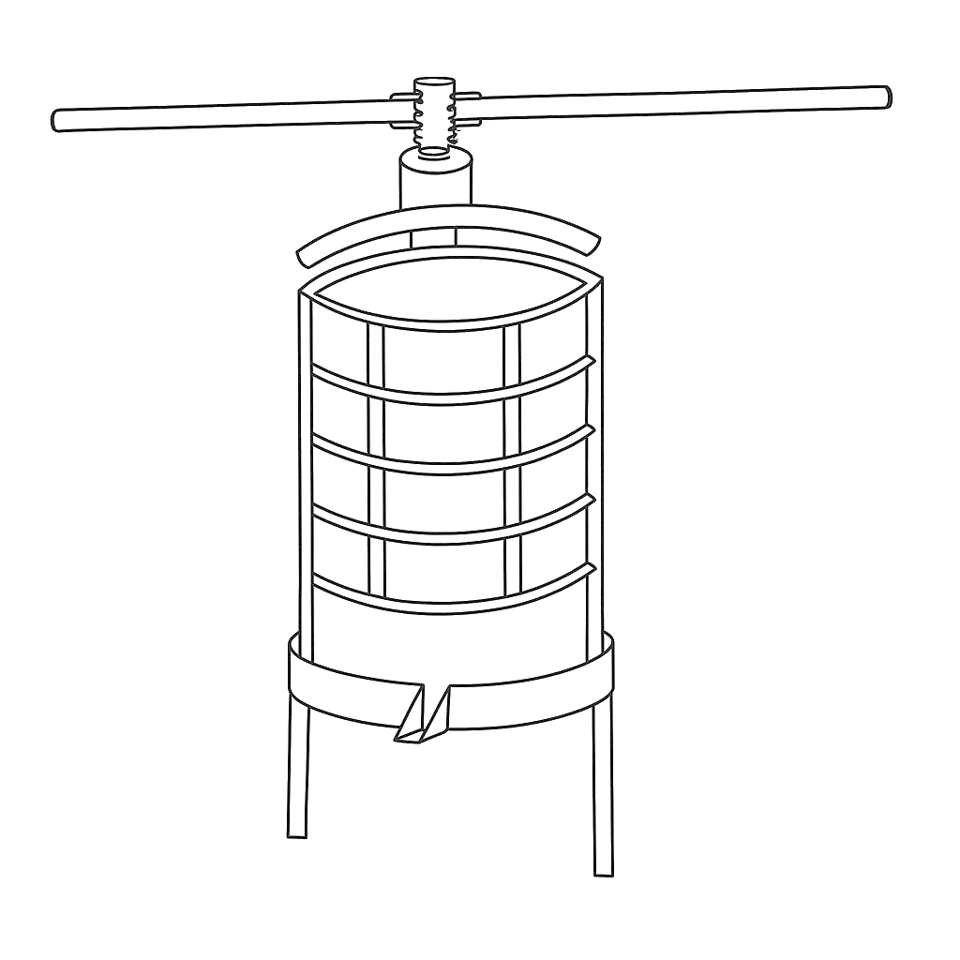
Frame
Press Shaft
Screw shaft
Discharge chute
Stand
Squeeze cage
Figure 2.2: Palm Oil Presser

CHAPTER THREE
WORK EXPERIENCE

3.1 CONSTRUCTION OF WINDOW PROTECTOR
The window protector constructed was of the following dimension 54mm x 1371mm.

3.1.1 Materials/Tools Used
Burglary-proof panels, welding machine, welding electrodes, protective wear (welding helmet, gloves, safety glasses), clamps or magnets, filler material, protective coating or paint.

3.1.2 Welding Process (Procedure)
- All necessary materials and tools for the welding process were gathered, including the burglary-proof panels, welding machine, welding electrodes, protective gear (welding helmet, gloves, safety glasses), and any additional accessories.
- The surfaces to be welded were cleaned and freed from rust, paint, or any other contaminants.
- The burglary-proof panels were properly aligned to ensure they fit securely together and formed a strong joint. Clamps or magnets were used to hold the panels in place during welding.
- Tack welds were performed at key points along the joint to temporarily secure the panels in place. These tack welds helped prevent the panels from shifting or moving during welding.
- The welding machine was used to perform the main welding passes along the entire length of the joint.
- The appropriate filler material was chosen based on the type of metal being welded and the welding process used.
- After completing the welding process, the welds were inspected for any defects or imperfections.

3.1.3 Finishing
- The welded joints were allowed to cool down gradually to avoid introducing stress or distortion.
- A visual inspection of the welded joints was performed to ensure they met the required quality standards.
- A protective coating or paint was applied to the welded joints to prevent corrosion and enhance the longevity of the burglary-proof structure. The constructed window protector is presented in Figure 3.1.

3.1.4 Precautions Observed
- All surfaces to be welded were cleaned thoroughly to remove rust, paint, or any contaminants.
- Proper alignment of the panels was ensured before welding.
- Protective gear, including welding helmets, gloves, and safety glasses, was worn at all times.
- Tack welds were used to prevent movement of the panels during the main welding process.
- Welded joints were allowed to cool gradually to avoid stress or distortion.
- A final inspection was conducted to check for any defects or imperfections in the welds.
- A protective coating or paint was applied to prevent corrosion.

1371mm
54mm

Figure 3.1: Window protector

3.2 CONSTRUCTION OF A PALM NUT POUNDER AND SELECTOR

3.2.1 Materials/Tools Used
The materials and tools used for the fabrication of the palm nut pounder and selector included mild steel sheets for the housing, steel rods for the pounding mechanism, a motor for automation, bearings, bolts, and paint for finishing. The tools included a welding machine, angle grinder, measuring tape, square, welding helmet, gloves, and a drill.

3.2.2 Fabrication Process (Procedure)
- The construction process began with measuring and cutting the steel sheets and rods to the required dimensions.
- The frame was assembled using steel rods and sheets, ensuring structural stability.
- The pounding chamber was welded securely, and the selector mechanism was installed for effective nut separation.
- Bearings and the motor were fitted to ensure smooth operation and efficiency.
- Once assembly was complete all edges were ground smooth to remove sharp surfaces.

3.2.3 Finishing
For finishing, the entire structure was cleaned to remove welding slag and debris. A primer was applied to prevent rust, followed by a coat of paint for durability and aesthetics. The pounder and selector were then tested for functionality, and any necessary adjustments were made. The constructed Palm nut pounder and selector is presented in Figure 3.2.

3.2.4 Precautions Observed
During the fabrication process, several safety measures were observed:
- Safety gear, including gloves, a welding helmet, and protective clothing, was worn to prevent injuries.
- The work area was kept clean and free of flammable materials to reduce the risk of accidents.
- Proper ventilation was ensured during welding to prevent inhalation of harmful fumes.
- All tools and electrical components were checked for proper functionality before use to prevent malfunctions.
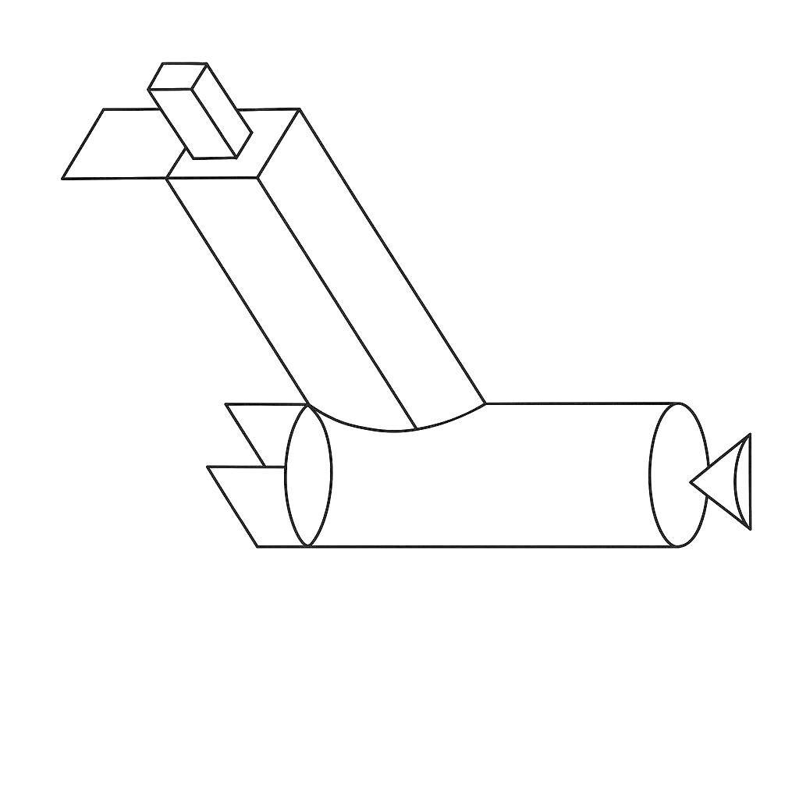
Feeder
Discharge chute
Stand
Selector
Frame
Pounder
Figure 3.2: Palm Nut Pounder and Selector

3.3 CONSTRUCTION OF A HANDRAIL WITH GALVANIZED PIPE

3.3.1 Materials Used
The materials used in the construction of the handrail included galvanized pipes, pipe fittings (elbows, tees, and connectors), base plates, welding machine, welding electrodes, measuring tape, level, clamps or magnets, cutting tools (hacksaw or pipe cutter), protective wear (welding helmet, gloves, safety glasses), filler material, and protective coating or paint for durability.

3.3.2 Welding Process (Procedure)
- All necessary materials and tools, including galvanized pipes, pipe fittings, welding machine, and safety gear, were gathered.
- The galvanized pipes were cleaned to remove any dirt, grease, or protective coatings that could interfere with welding.
- The pipes were measured and cut to the required lengths using a pipe cutter or hacksaw.
- The pipes and fittings were aligned properly to ensure a secure and precise assembly. Clamps or magnets were used to hold the components in place.
- Tack welds were applied at critical points to temporarily secure the components before performing the main welding process, preventing movement during welding.
- The welding machine was used to join the pipes and fittings securely, ensuring strong and smooth joints.
- The appropriate filler material was chosen based on the type of galvanized pipe being used.
- The welds were inspected for any defects or imperfections to ensure durability and strength.
- The welded joints were allowed to cool gradually to prevent stress or distortion.
- The base plates were securely welded to the bottom of the handrail posts for stability.
- The assembled handrail was tested for strength, stability, and proper alignment.

3.3.3 Finishing
- A thorough inspection of the welds and overall structure was performed to ensure all components were securely joined.
- The welded areas were cleaned, and any rough edges were ground smooth.
- A protective coating or paint was applied to the entire handrail to prevent rust and enhance durability. The constructed Handrail with Galvanized Pipe is presented in Figure 3.3.

3.3.4 Precautions Observed
- All pipe surfaces were cleaned thoroughly to remove contaminants before welding.
- Components were aligned carefully to ensure accurate assembly and strong joints before welding.
- Welding helmets, gloves, and safety glasses were worn at all times to ensure safety during the welding process.
- Tack welds were used to hold components in place and prevent movement during the main welding process.
- Welded joints were allowed to cool gradually to avoid introducing stress or warping.
- The base plates and structural components were securely fastened and aligned to ensure the handrail’s stability.
- A final inspection was conducted to check for defects in the welds and overall handrail assembly.
- A protective coating or paint was applied to prevent corrosion and increase the handrail’s lifespan.

Figure 3.3: Handrail with Galvanized Pipe

CHAPTER FOUR

CONCLUSION AND RECOMMENDATION

4.1 Conclusion
This report documented the comprehensive work experience involved in the construction of various metal structures, including a double door, window protector, metal door, and rolling metal gate. Each project highlighted the significance of proper materials, tools, and procedures essential for effective fabrication. The meticulous welding processes followed ensured strong and reliable joints, while the finishing techniques applied enhanced durability and aesthetic appeal.
Throughout the projects, strict adherence to safety precautions was observed, emphasizing the importance of protective gear and clean working conditions. The combination of theoretical knowledge and practical application not only bridged the gap between education and industry but also equipped students with invaluable skills relevant to their future careers. Overall, these experiences underscored the importance of quality craftsmanship and the role of industrial training in preparing students for the workforce.

4.2 Recommendations
Students often face challenges during their Students Industrial Work Experience Scheme (SIWES). To address this, it is recommended that the organization where the student undertakes SIWES provides an allowance to support them financially.
Additionally, the Industrial Training Fund (ITF) should ensure prompt payment of allowances once students complete their industrial training.
The institution should strive to establish connections with various companies to facilitate the placement of students during their SIWES period. This will help in evenly distributing students across different organizations, enhancing their learning experience.
Regular check-ins and evaluations should be conducted to ensure that the students are gaining practical and relevant experience.
Furthermore, the institution itself should provide consistent supervision, offering guidance and support to the students throughout their industrial training. This dual supervision will ensure a comprehensive and beneficial SIWES experience for all students.

REFERENCES
Green, J. N. (1964). Introduction to Technical Drawing: Metal work theory for school certificate and GCE, McGraw Hill, New York.
Chapman, W. (1972). Work shop technology. Published by Hodder Headline Group
Chiang, CK (1977). "Transport and optical properties of polythiazyl bromides: (SNBr0.4)x". Solid State Communications. 23 (9): 607–612
Green, J. N. (1964). Introduction to Technical Drawing: Metal work theory for school certificate and GCE, McGraw Hill, New York.
Kittel, C. (2018). Introduction to solid state physics. Paul McEuen (Global edition, [9th edition] ed.). Hoboken, NJ: Wiley. ISBN 978-1-119-45416-8.

